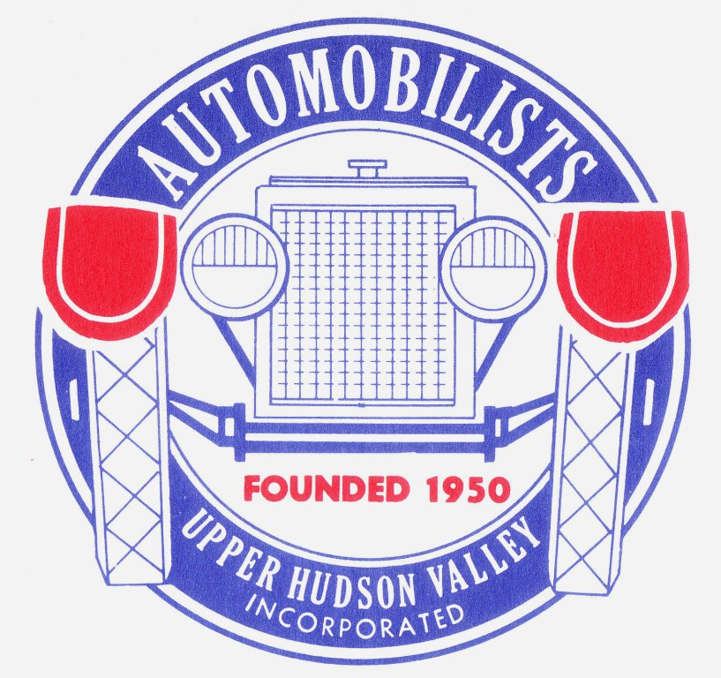
Automobilists of the Upper Hudson Valley, Inc.
Fundraiser/Cruisin
Saturday, September 7, 2019
9:30am to 3:30pm
At
Goldstein Buick
1671 Central Ave. Albany, NY
Trophies for the top 3 picks by the Goldstein Family

